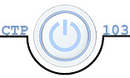**Julia Kovrigin**  **CTP 103**

# Lab 6: Wireless Networks (26 points)

Objectives:

* Define basic networking terminology
* Identify the components of a communication system
* List the steps to setup and configure a secure local area network

##### Section I: Wireless Basics – 16 points (2 points each)

1. Enter your name and section number at the top of this document.
2. Read the following online article about wireless networking [Wi-Fi - How to Build a Wireless Home Network Tutorial](http://compnetworking.about.com/cs/wirelessproducts/a/howtobuildwlan.htm)
3. Define these terms (use your own words):
   1. Access point: A device that creates WLAN by connecting to a wired or a hub via an Ethernet cable and projecting a signal to a certain area.
   2. Ad hoc network: Is a network that is composed of single devices communicating with each other directly. No centralized access points.
   3. Infrastructure network: Answer
   4. SSID: Service set identifier- the wi-fi network name
   5. MAC Address Filtering: a flinging system that limits the devices that can join the network
4. Answer these questions about a wireless network:
   1. What types of wireless signal interference can there be within a home network? home appliances; microwaves, baby monitors, garage door openers, brick and plaster walls.
   2. Define WEP, WPA, and WPA 2 and describe their difference? Which one is recommended and why? WEP (Wired Equivalent Privacy) is a network protocol that is supposed to give Wi-Fi/wireless network the same level of privacy as wired network by encrypting network communication so only computers can understand it. WPA (Wi-Fi Protected Access) is a different encryption protocol that replaced WEP. It has better encryption and authentication than WEP. WPA2 is another network protocol for protecting wireless networks. It has the capability to use two security measures; TKIP or AES. All of these are used to protect wireless networks. The first protocol was WEP, but it has been replaced by WPA because it became obsolete and WPA had improved encryption and authentication features. WPA2 is the recommended because it is more secure than its predecessors, if your access point or computer does not support WPA2, using WPA will be another good choice.
   3. You’ve already set up your firewall. Describe another step you can take to secure your wireless network against unauthorized access. You can enable MAC filtering, which only allows wireless access to trusted devices.

##### Section II: Sample wireless network – 10 points (2 points each)

1. Examine the screen capture below. They are the settings for the wireless network as AACC.

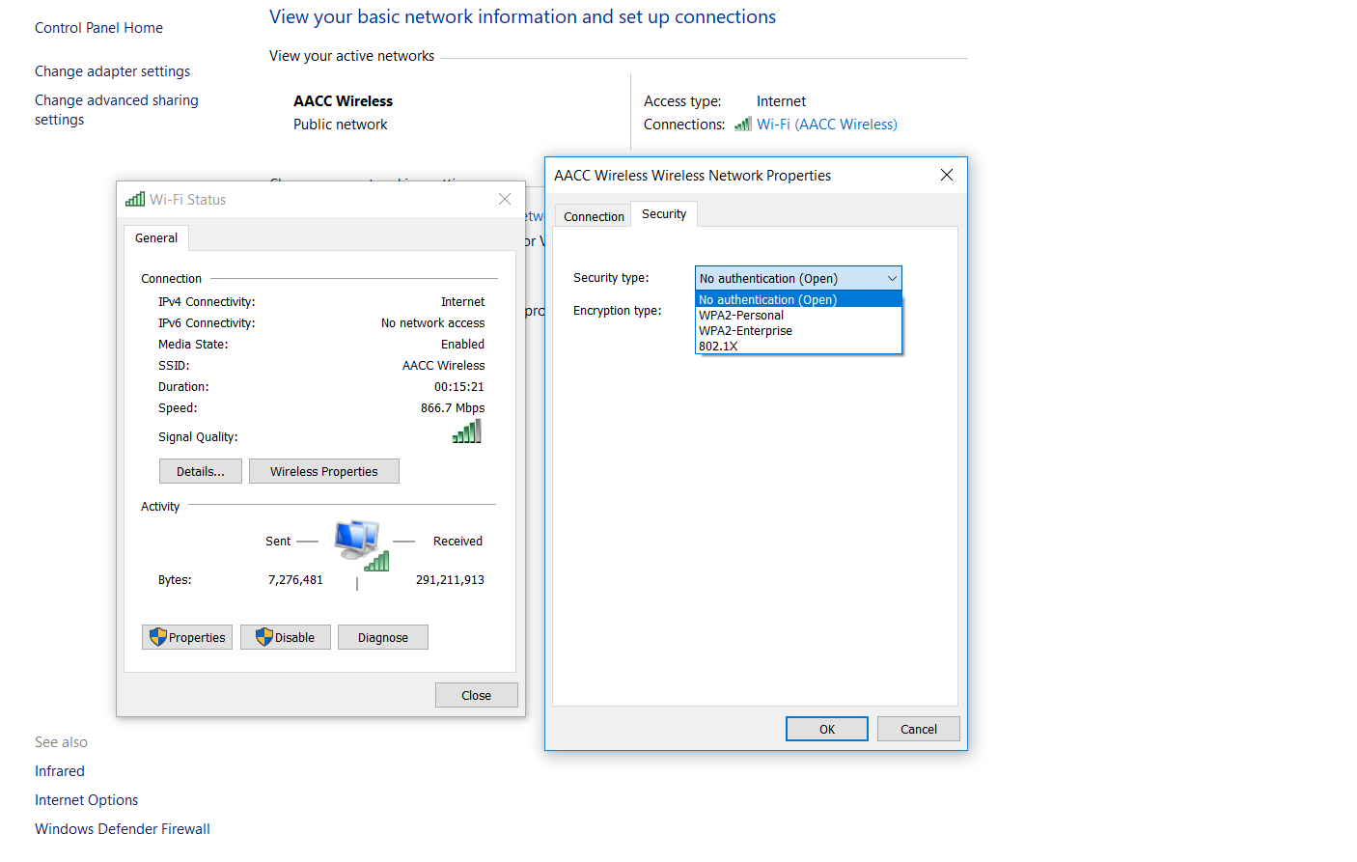

1. Use this information to answer the questions in this section.
   1. What is the service set identifier (SSID) for this networkAACC Wireless
   2. Would another computer connecting to this wireless network use the same SSID? Explain. Yes, because its connection to that wi-fi and will be using that ssid to get access to the router. Basically, using that router.
   3. Look at the AACC Wireless Network Properties dialog box above. Which wireless encryption method would be best for the *secured* school network? Explain why. (Note: this question is asking what the most secure option is.) WPA2-Enterprise. This encryption method would be best for a school since its an organization.
   4. Let’s say that the college decided that it would make the AACC Wireless network require a password, such as a MyAACC login. What implications does that have for the user that might want to have access to the network? The only users that will be allowed to use the network are the ones that have the password. This will make the network more secure for the users.
   5. The AACC Wireless network is an open connection requiring no password to join. What implications does that have for the user? Requiring no password for the Wi-Fi will make it easy for anyone who can catch the signal to use the wi-fi. This makes the network less secure for the users.

##### Submission Instructions

1. Make sure you have entered your name and section number at the top of the document.
2. Save the document as **LastName_Lab6.docx**, replacing YourLastName with YOUR last name.
3. Submit the assignment to the Lab 6 dropbox in Canvas by the due date.